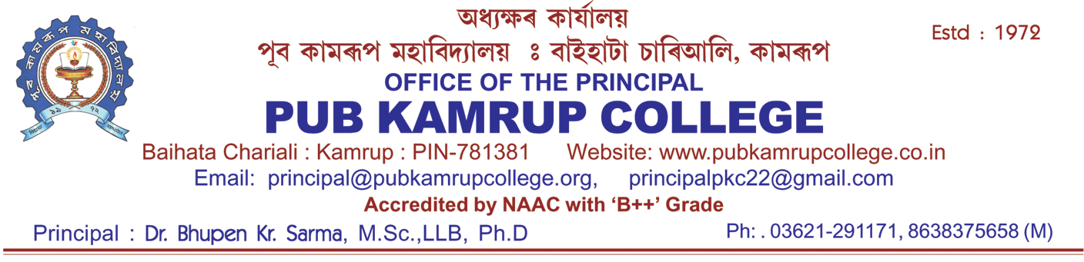
Ref.: PKC/Adm/Lateral Entry/2026/1 Date:22/08/2026
OFFICE OF THE PRINCIPAL
PUB KAMRUP COLLEGE
P.O.: BAIHATA CHARIALI, DIST.: KAMRUP
ASSAM, PIN-781381

ADMISSION NOTICE

FYUGP LATERAL ENTRY ADMISSION, 2026–27
It is hereby notified that applications are invited from eligible candidates seeking Lateral Entry Admission into the 3rd and 7th Semester of FYUGP programmes for the academic session 2026–27 at Pub Kamrup College, subject to availability of seats and fulfillment of the prescribed eligibility criteria. Candidates whose names appear in the Published List are informed to take admission from 24th to 26th August, 2026.

FEE STRUCTURE
Sl. No | Stream | Amount
1 | FYUGP BA 7th Sem | 3650/-
2 | FYUGP B.Sc 7th Sem | 4450/-
3 | FYUGP BA 3rd Sem | 4060/-
4 | FYUGP B.Sc 3rd Sem | 4960/-

DOCUMENTS REQUIRED
- Samarth Admission Application Form
- HSLC Admit Card/Marksheet
- HS Marksheet & Pass Certificate
- Previous Semester/Qualifying Examination Marksheet with Transfer Certificate from College
- Aadhaar Card
- Bank Passbook
- Caste/ EWS Certificate, if applicable
- Ration Card/Income Certificate for Fee Waiver, if applicable (For 3rd semester students)
Important Instructions
  - Admission will be granted subject to verification of original documents and fulfillment of eligibility criteria.
- Admission fees must be paid through digital payment modes only. Cash payment will not be accepted. Candidates are advised to bring an ATM/Debit Card with them.
  - Any discrepancy found in the submitted documents may lead to cancellation of admission.
  - Failure to complete the admission process with in the stipulated period shall result in cancellation of the allotted seat.

NB: Due to large number of applicants in 7th semester in Education, Political Science, Geography, Physics and Zoology, selected students' list for these departments will be published on 24th August 2026.

Students above CGPA 7.0 will be granted admission in 3rd semester

Sd/-
(Dr. B K Sarma)
Principal
Pub Kamrup College

