OFFICE OF THE PRINCIPAL
PUB KAMRUP COLLEGE
P.O.: BAIHATA CHARIALI, DIST.: KAMRUP
ASSAM, PIN-781381

Website: www.pubkamrupcollege.in
Email: principal@pubkamrupcollege.org
principalpkc22@gmail.com
Ph: . 03621-286300, 8638375658 (M)

From:
Dr. Bhupen Kr. Sarma, M.Sc.,LLB, Ph.D
Principal

ADMIT CARD

Recruitment for the post of Grade-IV
Venue of examination: Pub Kamrup College, Baihata Chariali
Date of examination: 11-12-2022
Time: 10:00 a.m. to 11:00 a.m.

Roll No. | PKC/Gr-IV/010
Candidate’s Name | ANAMIKA DEKA
Father’s Name | SADHI RAM DEKA
Address | VILL- AGDALA  PO & PS- BAIHATA CHARIALI  PIN-781381  PH NO.-8638223759

Candidate signature
Instruction to candidates

- Candidate must bring his/her admit card and all original testimonials along with xerox copy with him/her on the interview date.
- Candidate must reach the venue by 9:30 a.m.
- Admission of the candidate into the examination hall after 10 minutes of commencement of examination will not be allowed.
- Candidate will not be allowed to enter the examination hall with mobile phone and calculator or any other electronic devices.
- Candidate adopting unfair means will be disqualified.
- Candidate shall not be allowed to leave the examination hall without completing the stipulated time.
- Candidate need to carry at least one photo ID proof along with the admit card for verification purpose.
- In case of any error or misprint in the admit card, candidate must inform it to the invigilator.

OFFICE OF THE PRINCIPAL
PUB KAMRUP COLLEGE
P.O.: BAIHATA CHARIALI, DIST.: KAMRUP
ASSAM, PIN-781381

Website: www.pubkamrupcollege.in
Email: principal@pubkamrupcollege.org
principalpkc22@gmail.com
Ph: . 03621-286300, 8638375658 (M)

From:
Dr. Bhupen Kr. Sarma, M.Sc.,LLB, Ph.D
Principal

ADMIT CARD

Recruitment for the post of Grade-IV
Venue of examination: Pub Kamrup College, Baihata Chariali
Date of examination: 11-12-2022
Time: 10:00 a.m. to 11:00 a.m.

Roll No. | PKC/Gr-IV/015
Candidate’s Name | ANUP DEKA
Father’s Name | HARIHAR DEKA
Address | VILL & PO-BAIHATA  PS-KAMALPUR  DIST-KAMRUP  PIN-781380  PH NO.-7896222835

Candidate signature
Instruction to candidates

- Candidate must bring his/her admit card and all original testimonials along with xerox copy with him/her on the interview date.
- Candidate must reach the venue by 9:30 a.m.
- Admission of the candidate into the examination hall after 10 minutes of commencement of examination will not be allowed.
- Candidate will not be allowed to enter the examination hall with mobile phone and calculator or any other electronic devices.
- Candidate adopting unfair means will be disqualified.
- Candidate shall not be allowed to leave the examination hall without completing the stipulated time.
- Candidate need to carry at least one photo ID proof along with the admit card for verification purpose.
- In case of any error or misprint in the admit card, candidate must inform it to the invigilator.

OFFICE OF THE PRINCIPAL
PUB KAMRUP COLLEGE
P.O.: BAIHATA CHARIALI, DIST.: KAMRUP
ASSAM, PIN-781381

Website: www.pubkamrupcollege.in
Email: principal@pubkamrupcollege.org
principalpkc22@gmail.com
Ph: . 03621-286300, 8638375658 (M)

From:
Dr. Bhupen Kr. Sarma, M.Sc.,LLB, Ph.D
Principal

ADMIT CARD

Recruitment for the post of Grade-IV
Venue of examination: Pub Kamrup College, Baihata Chariali
Date of examination: 11-12-2022
Time: 10:00 a.m. to 11:00 a.m.

Roll No. | PKC/Gr-IV/016
Candidate’s Name | APSARA DEKA TALUKDAR
Father’s Name | NAGEN DEKA
Address | VILL- NIZKHAGATA  PO & PS-GHOGRAPAR  DST-NALBARI  PIN-781369  PH NO.-9365045440

Candidate signature
Instruction to candidates

- Candidate must bring his/her admit card and all original testimonials along with xerox copy with him/her on the interview date.
- Candidate must reach the venue by 9:30 a.m.
- Admission of the candidate into the examination hall after 10 minutes of commencement of examination will not be allowed.
- Candidate will not be allowed to enter the examination hall with mobile phone and calculator or any other electronic devices.
- Candidate adopting unfair means will be disqualified.
- Candidate shall not be allowed to leave the examination hall without completing the stipulated time.
- Candidate need to carry at least one photo ID proof along with the admit card for verification purpose.
- In case of any error or misprint in the admit card, candidate must inform it to the invigilator.

OFFICE OF THE PRINCIPAL
PUB KAMRUP COLLEGE
P.O.: BAIHATA CHARIALI, DIST.: KAMRUP
ASSAM, PIN-781381

Website: www.pubkamrupcollege.in
Email: principal@pubkamrupcollege.org
principalpkc22@gmail.com
Ph: . 03621-286300, 8638375658 (M)

From:
Dr. Bhupen Kr. Sarma, M.Sc.,LLB, Ph.D
Principal

ADMIT CARD

Recruitment for the post of Grade-IV
Venue of examination: Pub Kamrup College, Baihata Chariali
Date of examination: 11-12-2022
Time: 10:00 a.m. to 11:00 a.m.
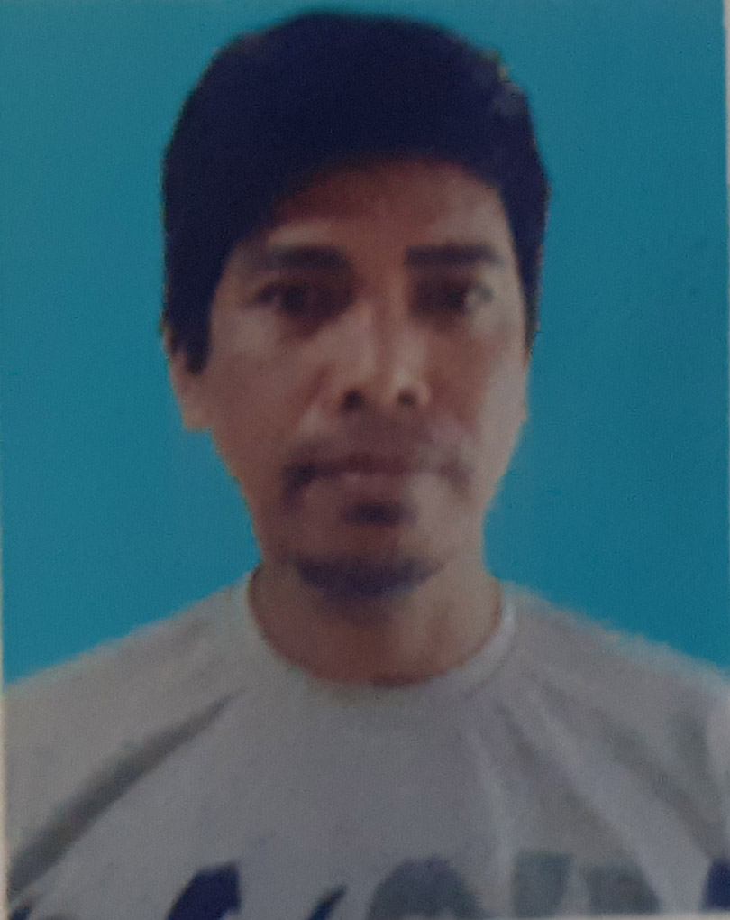
Roll No. | PKC/Gr-IV/037
Candidate’s Name | ASWINI DAS
Father’s Name | LATE JITEN DAS
Address | VILL- AGDALA  PO & PS- BAIHATA CHARIALI  PIN-781381  PH NO.-

Candidate signature
Instruction to candidates

- Candidate must bring his/her admit card and all original testimonials along with xerox copy with him/her on the interview date.
- Candidate must reach the venue by 9:30 a.m.
- Admission of the candidate into the examination hall after 10 minutes of commencement of examination will not be allowed.
- Candidate will not be allowed to enter the examination hall with mobile phone and calculator or any other electronic devices.
- Candidate adopting unfair means will be disqualified.
- Candidate shall not be allowed to leave the examination hall without completing the stipulated time.
- Candidate need to carry at least one photo ID proof along with the admit card for verification purpose.
- In case of any error or misprint in the admit card, candidate must inform it to the invigilator.

OFFICE OF THE PRINCIPAL
PUB KAMRUP COLLEGE
P.O.: BAIHATA CHARIALI, DIST.: KAMRUP
ASSAM, PIN-781381

Website: www.pubkamrupcollege.in
Email: principal@pubkamrupcollege.org
principalpkc22@gmail.com
Ph: . 03621-286300, 8638375658 (M)

From:
Dr. Bhupen Kr. Sarma, M.Sc.,LLB, Ph.D
Principal

ADMIT CARD

Recruitment for the post of Grade-IV
Venue of examination: Pub Kamrup College, Baihata Chariali
Date of examination: 11-12-2022
Time: 10:00 a.m. to 11:00 a.m.

Roll No. | PKC/Gr-IV/006
Candidate’s Name | BIKRAM TUMUNG
Father’s Name | RAMESWAR TUMUNG
Address | REWA MAHESWAR  PO-MALOIBARI  PS-KHETRI  KAMRUP (M)  PIN-782403  PH NO-6000089428

Candidate signature
Instruction to candidates

- Candidate must bring his/her admit card and all original testimonials along with xerox copy with him/her on the interview date.
- Candidate must reach the venue by 9:30 a.m.
- Admission of the candidate into the examination hall after 10 minutes of commencement of examination will not be allowed.
- Candidate will not be allowed to enter the examination hall with mobile phone and calculator or any other electronic devices.
- Candidate adopting unfair means will be disqualified.
- Candidate shall not be allowed to leave the examination hall without completing the stipulated time.
- Candidate need to carry at least one photo ID proof along with the admit card for verification purpose.
- In case of any error or misprint in the admit card, candidate must inform it to the invigilator.

OFFICE OF THE PRINCIPAL
PUB KAMRUP COLLEGE
P.O.: BAIHATA CHARIALI, DIST.: KAMRUP
ASSAM, PIN-781381

Website: www.pubkamrupcollege.in
Email: principal@pubkamrupcollege.org
principalpkc22@gmail.com
Ph: . 03621-286300, 8638375658 (M)

From:
Dr. Bhupen Kr. Sarma, M.Sc.,LLB, Ph.D
Principal

ADMIT CARD

Recruitment for the post of Grade-IV
Venue of examination: Pub Kamrup College, Baihata Chariali
Date of examination: 11-12-2022
Time: 10:00 a.m. to 11:00 a.m.


Roll No. | PKC/Gr-IV/004
Candidate’s Name | DEISUIHINGBE NRIAME
Father’s Name | LATE KEDEIHEUNG NRIAME
Address | VILL- HEJAICHAK  PO & PS- MAHUR  DIST-DIMA HASAO, ASSAM  PH NO.-9435470607

Candidate signature
Instruction to candidates

- Candidate must bring his/her admit card and all original testimonials along with xerox copy with him/her on the interview date.
- Candidate must reach the venue by 9:30 a.m.
- Admission of the candidate into the examination hall after 10 minutes of commencement of examination will not be allowed.
- Candidate will not be allowed to enter the examination hall with mobile phone and calculator or any other electronic devices.
- Candidate adopting unfair means will be disqualified.
- Candidate shall not be allowed to leave the examination hall without completing the stipulated time.
- Candidate need to carry at least one photo ID proof along with the admit card for verification purpose.
- In case of any error or misprint in the admit card, candidate must inform it to the invigilator.

OFFICE OF THE PRINCIPAL
PUB KAMRUP COLLEGE
P.O.: BAIHATA CHARIALI, DIST.: KAMRUP
ASSAM, PIN-781381

Website: www.pubkamrupcollege.in
Email: principal@pubkamrupcollege.org
principalpkc22@gmail.com
Ph: . 03621-286300, 8638375658 (M)

From:
Dr. Bhupen Kr. Sarma, M.Sc.,LLB, Ph.D
Principal

ADMIT CARD

Recruitment for the post of Grade-IV
Venue of examination: Pub Kamrup College, Baihata Chariali
Date of examination: 11-12-2022
Time: 10:00 a.m. to 11:00 a.m.


Roll No. | PKC/Gr-IV/003
Candidate’s Name | DIGANTA DEKARAJA
Father’s Name | C/O LATE ANANDA DEKARAJA
Address | VILL- GODWIN BEY GAON  PO-DON- KAMUKAM  PS-BAITHALANGSO  DIST-WEST KARBI ANGLONG

Candidate signature
Instruction to candidates

- Candidate must bring his/her admit card and all original testimonials along with xerox copy with him/her on the interview date.
- Candidate must reach the venue by 9:30 a.m.
- Admission of the candidate into the examination hall after 10 minutes of commencement of examination will not be allowed.
- Candidate will not be allowed to enter the examination hall with mobile phone and calculator or any other electronic devices.
- Candidate adopting unfair means will be disqualified.
- Candidate shall not be allowed to leave the examination hall without completing the stipulated time.
- Candidate need to carry at least one photo ID proof along with the admit card for verification purpose.
- In case of any error or misprint in the admit card, candidate must inform it to the invigilator.

OFFICE OF THE PRINCIPAL
PUB KAMRUP COLLEGE
P.O.: BAIHATA CHARIALI, DIST.: KAMRUP
ASSAM, PIN-781381

Website: www.pubkamrupcollege.in
Email: principal@pubkamrupcollege.org
principalpkc22@gmail.com
Ph: . 03621-286300, 8638375658 (M)

From:
Dr. Bhupen Kr. Sarma, M.Sc.,LLB, Ph.D
Principal

ADMIT CARD

Recruitment for the post of Grade-IV
Venue of examination: Pub Kamrup College, Baihata Chariali
Date of examination: 11-12-2022
Time: 10:00 a.m. to 11:00 a.m.

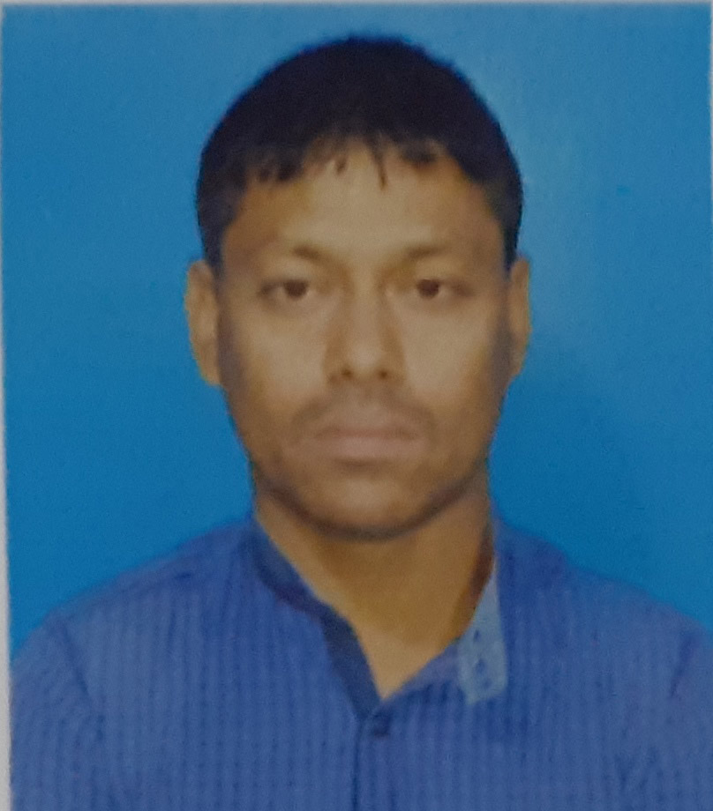
Roll No. | PKC/Gr-IV/031
Candidate’s Name | DIGANTA KAKATI
Father’s Name | BAPURAM KAKATI
Address | VILL- NAGAON  PO & PS- BAIHATA CHARIALI  PIN-781381  PH NO.-8811974666

Candidate signature
Instruction to candidates

- Candidate must bring his/her admit card and all original testimonials along with xerox copy with him/her on the interview date.
- Candidate must reach the venue by 9:30 a.m.
- Admission of the candidate into the examination hall after 20 minutes of commencement of examination will not be allowed.
- Candidate will not be allowed to enter the examination hall with mobile phone and calculator or any other electronic devices.
- Candidate adopting unfair means will be disqualified.
- Candidate shall not be allowed to leave the examination hall without completing the stipulated time.
- Candidate need to carry at least one photo ID proof along with the admit card for verification purpose.
- In case of any error or misprint in the admit card, candidate must inform it to the invigilator.

OFFICE OF THE PRINCIPAL
PUB KAMRUP COLLEGE
P.O.: BAIHATA CHARIALI, DIST.: KAMRUP
ASSAM, PIN-781381

Website: www.pubkamrupcollege.in
Email: principal@pubkamrupcollege.org
principalpkc22@gmail.com
Ph: . 03621-286300, 8638375658 (M)

From:
Dr. Bhupen Kr. Sarma, M.Sc.,LLB, Ph.D
Principal

ADMIT CARD

Recruitment for the post of Grade-IV
Venue of examination: Pub Kamrup College, Baihata Chariali
Date of examination: 11-12-2022
Time: 10:00 a.m. to 11:00 a.m.


Roll No. | PKC/Gr-IV/035
Candidate’s Name | DIP JYOTI TALUKDAR
Father’s Name | HARICHANDRA TALUKDAR
Address | VILL- GANAKJHAR  PO-MAHAJANPARA  PS-BAIHATA CHARIALI  Candidate signature  PIN-781366

Instruction to candidates

- Candidate must bring his/her admit card and all original testimonials along with xerox copy with him/her on the interview date.
- Candidate must reach the venue by 9:30 a.m.
- Admission of the candidate into the examination hall after 10 minutes of commencement of examination will not be allowed.
- Candidate will not be allowed to enter the examination hall with mobile phone and calculator or any other electronic devices.
- Candidate adopting unfair means will be disqualified.
- Candidate shall not be allowed to leave the examination hall without completing the stipulated time.
- Candidate need to carry at least one photo ID proof along with the admit card for verification purpose.
- In case of any error or misprint in the admit card, candidate must inform it to the invigilator.

OFFICE OF THE PRINCIPAL
PUB KAMRUP COLLEGE
P.O.: BAIHATA CHARIALI, DIST.: KAMRUP
ASSAM, PIN-781381

Website: www.pubkamrupcollege.in
Email: principal@pubkamrupcollege.org
principalpkc22@gmail.com
Ph: . 03621-286300, 8638375658 (M)

From:
Dr. Bhupen Kr. Sarma, M.Sc.,LLB, Ph.D
Principal

ADMIT CARD

Recruitment for the post of Grade-IV
Venue of examination: Pub Kamrup College, Baihata Chariali
Date of examination: 11-12-2022
Time: 10:00 a.m. to 11:00 a.m.

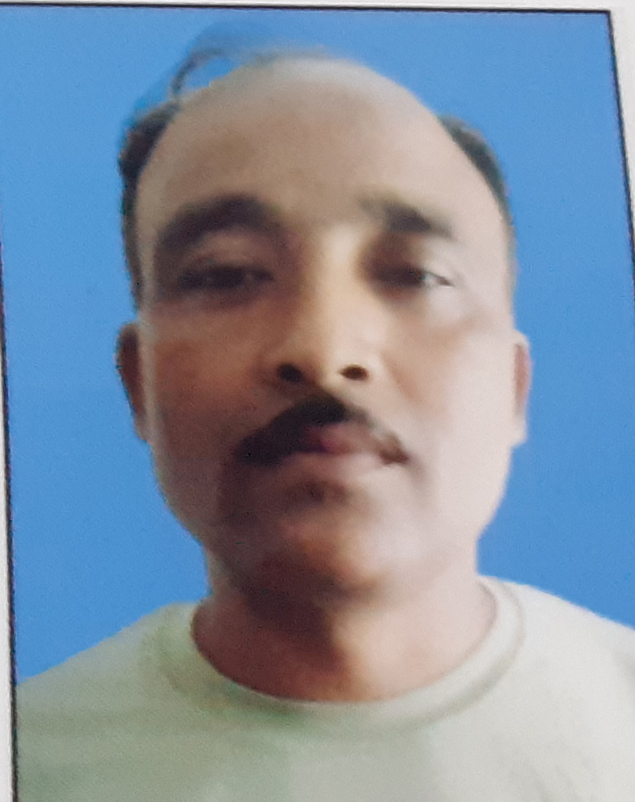
Roll No. | PKC/Gr-IV/029
Candidate’s Name | GAGAN DAS
Father’s Name | BHUMIDHAR DAS
Address | VILL- AGDALA  PO & PS- BAIHATA CHARIALI  PIN-781381  PH NO.-9101584057

Candidate signature
Instruction to candidates

- Candidate must bring his/her admit card and all original testimonials along with xerox copy with him/her on the interview date.
- Candidate must reach the venue by 9:30 a.m.
- Admission of the candidate into the examination hall after 10 minutes of commencement of examination will not be allowed.
- Candidate will not be allowed to enter the examination hall with mobile phone and calculator or any other electronic devices.
- Candidate adopting unfair means will be disqualified.
- Candidate shall not be allowed to leave the examination hall without completing the stipulated time.
- Candidate need to carry at least one photo ID proof along with the admit card for verification purpose.
- In case of any error or misprint in the admit card, candidate must inform it to the invigilator.

OFFICE OF THE PRINCIPAL
PUB KAMRUP COLLEGE
P.O.: BAIHATA CHARIALI, DIST.: KAMRUP
ASSAM, PIN-781381

Website: www.pubkamrupcollege.in
Email: principal@pubkamrupcollege.org
principalpkc22@gmail.com
Ph: . 03621-286300, 8638375658 (M)

From:
Dr. Bhupen Kr. Sarma, M.Sc.,LLB, Ph.D
Principal

ADMIT CARD

Recruitment for the post of Grade-IV
Venue of examination: Pub Kamrup College, Baihata Chariali
Date of examination: 11-12-2022
Time: 10:00 a.m. to 11:00 a.m.
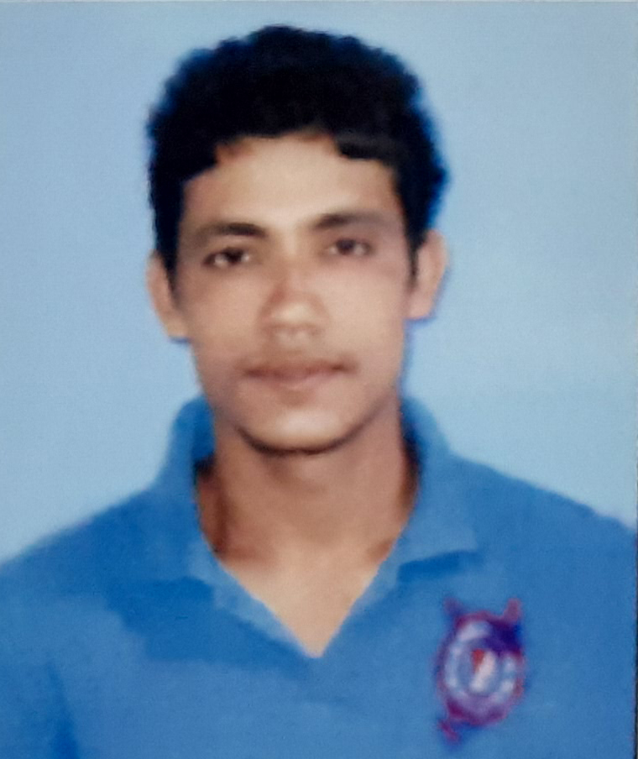
Roll No. | PKC/Gr-IV/026
Candidate’s Name | HIRAK DAS
Father’s Name | KAMALA DAS
Address | VILL- ALEKJARI  PO-KALAZAL  PS-KAMALPUR  PIN-781380  PH NO.-8822573214

Candidate signature
Instruction to candidates

- Candidate must bring his/her admit card and all original testimonials along with xerox copy with him/her on the interview date.
- Candidate must reach the venue by 9:30 a.m.
- Admission of the candidate into the examination hall after 10 minutes of commencement of examination will not be allowed.
- Candidate will not be allowed to enter the examination hall with mobile phone and calculator or any other electronic devices.
- Candidate adopting unfair means will be disqualified.
- Candidate shall not be allowed to leave the examination hall without completing the stipulated time.
- Candidate need to carry at least one photo ID proof along with the admit card for verification purpose.
- In case of any error or misprint in the admit card, candidate must inform it to the invigilator.

OFFICE OF THE PRINCIPAL
PUB KAMRUP COLLEGE
P.O.: BAIHATA CHARIALI, DIST.: KAMRUP
ASSAM, PIN-781381

Website: www.pubkamrupcollege.in
Email: principal@pubkamrupcollege.org
principalpkc22@gmail.com
Ph: . 03621-286300, 8638375658 (M)

From:
Dr. Bhupen Kr. Sarma, M.Sc.,LLB, Ph.D
Principal

ADMIT CARD

Recruitment for the post of Grade-IV
Venue of examination: Pub Kamrup College, Baihata Chariali
Date of examination: 11-12-2022
Time: 10:00 a.m. to 11:00 a.m.


Roll No. | PKC/Gr-IV/033
Candidate’s Name | HIRAKJYOTI KAKATI
Father’s Name | TARUN CHANDRA KAKATI
Address | VILL- NAGAON  PO & PS- BAIHATA CHARIALI  PIN-781381

Candidate signature
Instruction to candidates

- Candidate must bring his/her admit card and all original testimonials along with xerox copy with him/her on the interview date.
- Candidate must reach the venue by 9:30 a.m.
- Admission of the candidate into the examination hall after 10 minutes of commencement of examination will not be allowed.
- Candidate will not be allowed to enter the examination hall with mobile phone and calculator or any other electronic devices.
- Candidate adopting unfair means will be disqualified.
- Candidate shall not be allowed to leave the examination hall without completing the stipulated time.
- Candidate need to carry at least one photo ID proof along with the admit card for verification purpose.
- In case of any error or misprint in the admit card, candidate must inform it to the invigilator.

OFFICE OF THE PRINCIPAL
PUB KAMRUP COLLEGE
P.O.: BAIHATA CHARIALI, DIST.: KAMRUP
ASSAM, PIN-781381

Website: www.pubkamrupcollege.in
Email: principal@pubkamrupcollege.org
principalpkc22@gmail.com
Ph: . 03621-286300, 8638375658 (M)

From:
Dr. Bhupen Kr. Sarma, M.Sc.,LLB, Ph.D
Principal

ADMIT CARD

Recruitment for the post of Grade-IV
Venue of examination: Pub Kamrup College, Baihata Chariali
Date of examination: 11-12-2022
Time: 10:00 a.m. to 11:00 a.m.

Roll No. | PKC/Gr-IV/023
Candidate’s Name | HIRAKJYOTI KAKATI
Father’s Name | TARUN CHANDRA KAKATI
Address | VILL- NAGAON  PO & PS- BAIHATA CHARIALI  PIN-781381

Candidate signature
Instruction to candidates

- Candidate must bring his/her admit card and all original testimonials along with xerox copy with him/her on the interview date.
- Candidate must reach the venue by 9:30 a.m.
- Admission of the candidate into the examination hall after 10 minutes of commencement of examination will not be allowed.
- Candidate will not be allowed to enter the examination hall with mobile phone and calculator or any other electronic devices.
- Candidate adopting unfair means will be disqualified.
- Candidate shall not be allowed to leave the examination hall without completing the stipulated time.
- Candidate need to carry at least one photo ID proof along with the admit card for verification purpose.
- In case of any error or misprint in the admit card, candidate must inform it to the invigilator.

OFFICE OF THE PRINCIPAL
PUB KAMRUP COLLEGE
P.O.: BAIHATA CHARIALI, DIST.: KAMRUP
ASSAM, PIN-781381

Website: www.pubkamrupcollege.in
Email: principal@pubkamrupcollege.org
principalpkc22@gmail.com
Ph: . 03621-286300, 8638375658 (M)

From:
Dr. Bhupen Kr. Sarma, M.Sc.,LLB, Ph.D
Principal

ADMIT CARD

Recruitment for the post of Grade-IV
Venue of examination: Pub Kamrup College, Baihata Chariali
Date of examination: 11-12-2022
Time: 10:00 a.m. to 11:00 a.m.
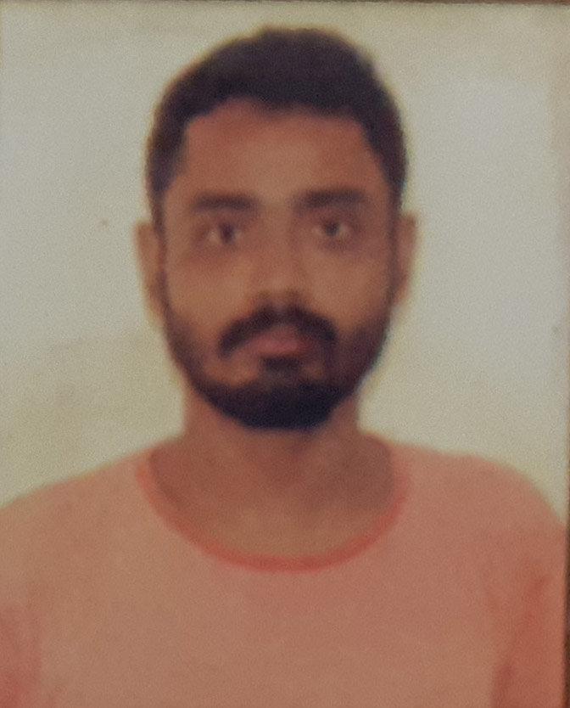
Roll No. | PKC/Gr-IV/030
Candidate’s Name | HRISHIKESH DAS
Father’s Name | LATE GIRISH CH. DAS
Address | VILL- NAGAON  PO & PS- BAIHATA CHARIALI  PIN-781381  PH NO.-8011828099

Candidate signature
Instruction to candidates

- Candidate must bring his/her admit card and all original testimonials along with xerox copy with him/her on the interview date.
- Candidate must reach the venue by 9:30 a.m.
- Admission of the candidate into the examination hall after 10 minutes of commencement of examination will not be allowed.
- Candidate will not be allowed to enter the examination hall with mobile phone and calculator or any other electronic devices.
- Candidate adopting unfair means will be disqualified.
- Candidate shall not be allowed to leave the examination hall without completing the stipulated time.
- Candidate need to carry at least one photo ID proof along with the admit card for verification purpose.
- In case of any error or misprint in the admit card, candidate must inform it to the invigilator.

OFFICE OF THE PRINCIPAL
PUB KAMRUP COLLEGE
P.O.: BAIHATA CHARIALI, DIST.: KAMRUP
ASSAM, PIN-781381

Website: www.pubkamrupcollege.in
Email: principal@pubkamrupcollege.org
principalpkc22@gmail.com
Ph: . 03621-286300, 8638375658 (M)

From:
Dr. Bhupen Kr. Sarma, M.Sc.,LLB, Ph.D
Principal

ADMIT CARD

Recruitment for the post of Grade-IV
Venue of examination: Pub Kamrup College, Baihata Chariali
Date of examination: 11-12-2022
Time: 10:00 a.m. to 11:00 a.m.
Roll No. | PKC/Gr-IV/020
Candidate’s Name | HRISHIKESH DAS
Father’s Name | LATE GIRISH CH. DAS
Address | VILL- NAGAON  PO & PS- BAIHATA CHARIALI  PIN-781381  PH NO.-8011828099

Candidate signature
Instruction to candidates

- Candidate must bring his/her admit card and all original testimonials along with xerox copy with him/her on the interview date.
- Candidate must reach the venue by 9:30 a.m.
- Admission of the candidate into the examination hall after 10 minutes of commencement of examination will not be allowed.
- Candidate will not be allowed to enter the examination hall with mobile phone and calculator or any other electronic devices.
- Candidate adopting unfair means will be disqualified.
- Candidate shall not be allowed to leave the examination hall without completing the stipulated time.
- Candidate need to carry at least one photo ID proof along with the admit card for verification purpose.
- In case of any error or misprint in the admit card, candidate must inform it to the invigilator.

OFFICE OF THE PRINCIPAL
PUB KAMRUP COLLEGE
P.O.: BAIHATA CHARIALI, DIST.: KAMRUP
ASSAM, PIN-781381

Website: www.pubkamrupcollege.in
Email: principal@pubkamrupcollege.org
principalpkc22@gmail.com
Ph: . 03621-286300, 8638375658 (M)

From:
Dr. Bhupen Kr. Sarma, M.Sc.,LLB, Ph.D
Principal

ADMIT CARD

Recruitment for the post of Grade-IV
Venue of examination: Pub Kamrup College, Baihata Chariali
Date of examination: 11-12-2022
Time: 10:00 a.m. to 11:00 a.m.
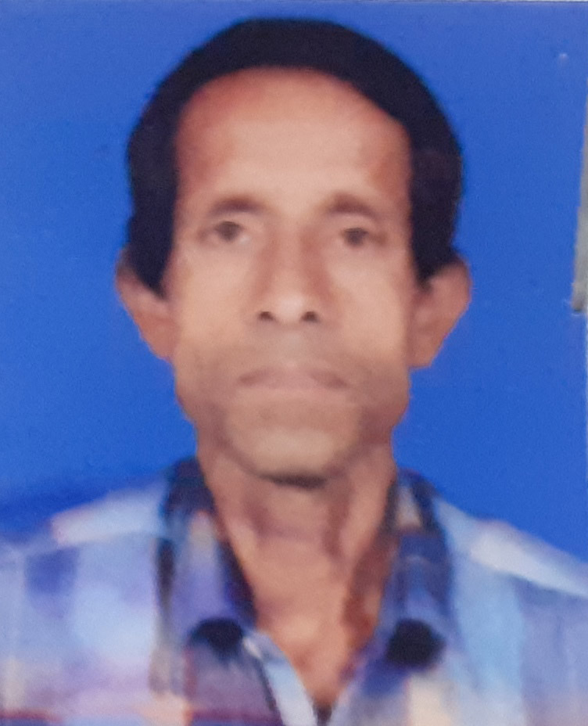
Roll No. | PKC/Gr-IV/009
Candidate’s Name | JAGANNATHA PATOWARY
Father’s Name | LATE PRAFULLA PATOWARY
Address | VILL & PO- BIHDIA  PS-BAIHATA CHARIALI  PIN-781381  PH NO.-766492812

Candidate signature
Instruction to candidates

- Candidate must bring his/her admit card and all original testimonials along with xerox copy with him/her on the interview date.
- Candidate must reach the venue by 9:30 a.m.
- Admission of the candidate into the examination hall after 10 minutes of commencement of examination will not be allowed.
- Candidate will not be allowed to enter the examination hall with mobile phone and calculator or any other electronic devices.
- Candidate adopting unfair means will be disqualified.
- Candidate shall not be allowed to leave the examination hall without completing the stipulated time.
- Candidate need to carry at least one photo ID proof along with the admit card for verification purpose.
- In case of any error or misprint in the admit card, candidate must inform it to the invigilator.

OFFICE OF THE PRINCIPAL
PUB KAMRUP COLLEGE
P.O.: BAIHATA CHARIALI, DIST.: KAMRUP
ASSAM, PIN-781381

Website: www.pubkamrupcollege.in
Email: principal@pubkamrupcollege.org
principalpkc22@gmail.com
Ph: . 03621-286300, 8638375658 (M)

From:
Dr. Bhupen Kr. Sarma, M.Sc.,LLB, Ph.D
Principal

ADMIT CARD

Recruitment for the post of Grade-IV
Venue of examination: Pub Kamrup College, Baihata Chariali
Date of examination: 11-12-2022
Time: 10:00 a.m. to 11:00 a.m.


Roll No. | PKC/Gr-IV/024
Candidate’s Name | JIAUL HAQUE
Father’s Name | MAJNUR ALI
Address | VILL- NAGAON  PO & PS- BAIHATA CHARIALI  PIN-781381  Candidate signature  PH NO.-9707043896

Instruction to candidates

- Candidate must bring his/her admit card and all original testimonials along with xerox copy with him/her on the interview date.
- Candidate must reach the venue by 9:30 a.m.
- Admission of the candidate into the examination hall after 10 minutes of commencement of examination will not be allowed.
- Candidate will not be allowed to enter the examination hall with mobile phone and calculator or any other electronic devices.
- Candidate adopting unfair means will be disqualified.
- Candidate shall not be allowed to leave the examination hall without completing the stipulated time.
- Candidate need to carry at least one photo ID proof along with the admit card for verification purpose.
- In case of any error or misprint in the admit card, candidate must inform it to the invigilator.

OFFICE OF THE PRINCIPAL
PUB KAMRUP COLLEGE
P.O.: BAIHATA CHARIALI, DIST.: KAMRUP
ASSAM, PIN-781381

Website: www.pubkamrupcollege.in
Email: principal@pubkamrupcollege.org
principalpkc22@gmail.com
Ph: . 03621-286300, 8638375658 (M)

From:
Dr. Bhupen Kr. Sarma, M.Sc.,LLB, Ph.D
Principal

ADMIT CARD

Recruitment for the post of Grade-IV
Venue of examination: Pub Kamrup College, Baihata Chariali
Date of examination: 11-12-2022
Time: 10:00 a.m. to 11:00 a.m.


Roll No. | PKC/Gr-IV/002
Candidate’s Name | JOELBE RIAME
Father’s Name | RONGPIBE RIAME
Address | VILL- NEW BORO HAFLONG  PO & PS- HAFLONG  Candidate signature  DIST-DIMA HASAO  PIN-788819  PH NO.-7002472052

Instruction to candidates

- Candidate must bring his/her admit card and all original testimonials along with xerox copy with him/her on the interview date.
- Candidate must reach the venue by 9:30 a.m.
- Admission of the candidate into the examination hall after 10 minutes of commencement of examination will not be allowed.
- Candidate will not be allowed to enter the examination hall with mobile phone and calculator or any other electronic devices.
- Candidate adopting unfair means will be disqualified.
- Candidate shall not be allowed to leave the examination hall without completing the stipulated time.
- Candidate need to carry at least one photo ID proof along with the admit card for verification purpose.
- In case of any error or misprint in the admit card, candidate must inform it to the invigilator.

OFFICE OF THE PRINCIPAL
PUB KAMRUP COLLEGE
P.O.: BAIHATA CHARIALI, DIST.: KAMRUP
ASSAM, PIN-781381

Website: www.pubkamrupcollege.in
Email: principal@pubkamrupcollege.org
principalpkc22@gmail.com
Ph: . 03621-286300, 8638375658 (M)

From:
Dr. Bhupen Kr. Sarma, M.Sc.,LLB, Ph.D
Principal

ADMIT CARD

Recruitment for the post of Grade-IV
Venue of examination: Pub Kamrup College, Baihata Chariali
Date of examination: 11-12-2022
Time: 10:00 a.m. to 11:00 a.m.

Roll No. | PKC/Gr-IV/014
Candidate’s Name | JYOTI MAHANTA
Father’s Name | LATE KANDARPA MAHANTA
Address | VILL-BARDADHI  PO-GARUAH  PS-HAJO  DIST-KAMRUP  PIN-781102  PH NO.-9954607561

Candidate signature
Instruction to candidates

- Candidate must bring his/her admit card and all original testimonials along with xerox copy with him/her on the interview date.
- Candidate must reach the venue by 9:30 a.m.
- Admission of the candidate into the examination hall after 10 minutes of commencement of examination will not be allowed.
- Candidate will not be allowed to enter the examination hall with mobile phone and calculator or any other electronic devices.
- Candidate adopting unfair means will be disqualified.
- Candidate shall not be allowed to leave the examination hall without completing the stipulated time.
- Candidate need to carry at least one photo ID proof along with the admit card for verification purpose.
- In case of any error or misprint in the admit card, candidate must inform it to the invigilator.

OFFICE OF THE PRINCIPAL
PUB KAMRUP COLLEGE
P.O.: BAIHATA CHARIALI, DIST.: KAMRUP
ASSAM, PIN-781381

Website: www.pubkamrupcollege.in
Email: principal@pubkamrupcollege.org
principalpkc22@gmail.com
Ph: . 03621-286300, 8638375658 (M)

From:
Dr. Bhupen Kr. Sarma, M.Sc.,LLB, Ph.D
Principal

ADMIT CARD

Recruitment for the post of Grade-IV
Venue of examination: Pub Kamrup College, Baihata Chariali
Date of examination: 11-12-2022
Time: 10:00 a.m. to 11:00 a.m.

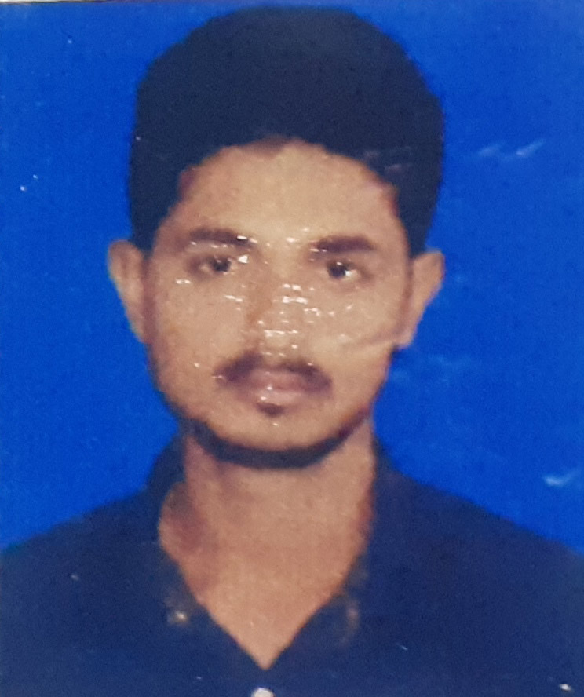
Roll No. | PKC/Gr-IV/021
Candidate’s Name | KOUSHIK KALITA
Father’s Name | GHANAKANTA KALITA
Address | VILL-KSHUDRA PALAHA  PO & PS- BAIHATA CHARIALI  DIST-KAMRUP  PIN-781381

Candidate signature
Instruction to candidates

- Candidate must bring his/her admit card and all original testimonials along with xerox copy with him/her on the interview date.
- Candidate must reach the venue by 9:30 a.m.
- Admission of the candidate into the examination hall after 10 minutes of commencement of examination will not be allowed.
- Candidate will not be allowed to enter the examination hall with mobile phone and calculator or any other electronic devices.
- Candidate adopting unfair means will be disqualified.
- Candidate shall not be allowed to leave the examination hall without completing the stipulated time.
- Candidate need to carry at least one photo ID proof along with the admit card for verification purpose.
- In case of any error or misprint in the admit card, candidate must inform it to the invigilator.

OFFICE OF THE PRINCIPAL
PUB KAMRUP COLLEGE
P.O.: BAIHATA CHARIALI, DIST.: KAMRUP
ASSAM, PIN-781381

Website: www.pubkamrupcollege.in
Email: principal@pubkamrupcollege.org
principalpkc22@gmail.com
Ph: . 03621-286300, 8638375658 (M)

From:
Dr. Bhupen Kr. Sarma, M.Sc.,LLB, Ph.D
Principal

ADMIT CARD

Recruitment for the post of Grade-IV
Venue of examination: Pub Kamrup College, Baihata Chariali
Date of examination: 11-12-2022
Time: 10:00 a.m. to 11:00 a.m.

Roll No. | PKC/Gr-IV/017
Candidate’s Name | MANJULA DEKA
Father’s Name | SISHU RAM DEKA
Address | VILL- AGDALA  PO & PS- BAIHATA CHARIALI  PIN-781381  PH NO.-9954817441

Candidate signature
Instruction to candidates

- Candidate must bring his/her admit card and all original testimonials along with xerox copy with him/her on the interview date.
- Candidate must reach the venue by 9:30 a.m.
- Admission of the candidate into the examination hall after 10 minutes of commencement of examination will not be allowed.
- Candidate will not be allowed to enter the examination hall with mobile phone and calculator or any other electronic devices.
- Candidate adopting unfair means will be disqualified.
- Candidate shall not be allowed to leave the examination hall without completing the stipulated time.
- Candidate need to carry at least one photo ID proof along with the admit card for verification purpose.
- In case of any error or misprint in the admit card, candidate must inform it to the invigilator.

OFFICE OF THE PRINCIPAL
PUB KAMRUP COLLEGE
P.O.: BAIHATA CHARIALI, DIST.: KAMRUP
ASSAM, PIN-781381

Website: www.pubkamrupcollege.in
Email: principal@pubkamrupcollege.org
principalpkc22@gmail.com
Ph: . 03621-286300, 8638375658 (M)

From:
Dr. Bhupen Kr. Sarma, M.Sc.,LLB, Ph.D
Principal

ADMIT CARD

Recruitment for the post of Grade-IV
Venue of examination: Pub Kamrup College, Baihata Chariali
Date of examination: 11-12-2022
Time: 10:00 a.m. to 11:00 a.m.

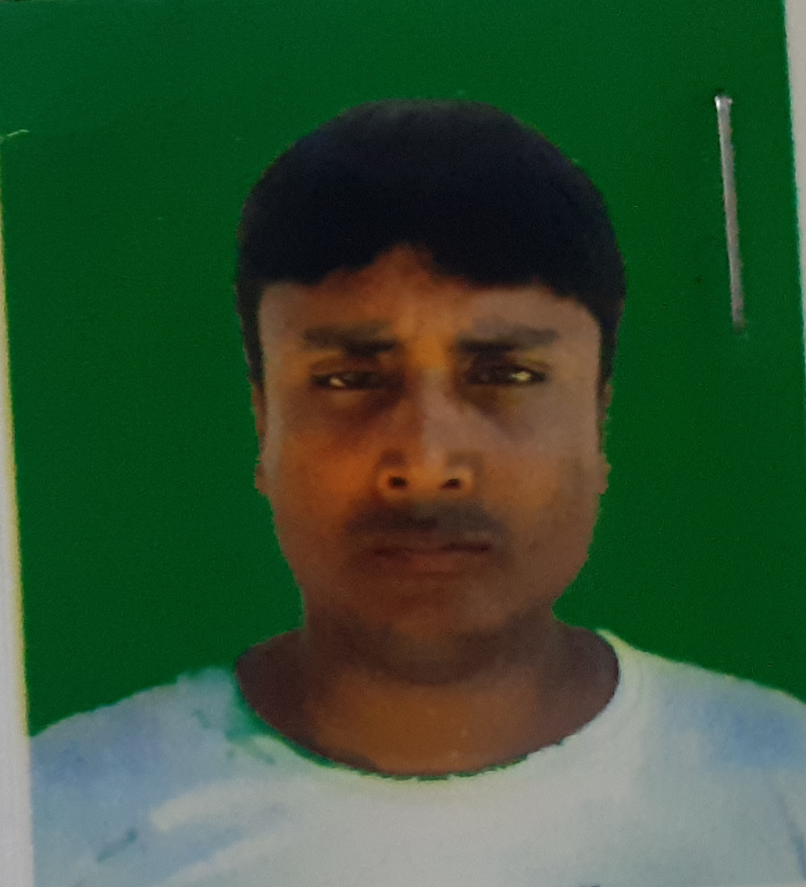
Roll No. | PKC/Gr-IV/034
Candidate’s Name | MRIDUL KUMAR
Father’s Name | CHANDRA DHAR KUMAR
Address | VILL- GANAKJHAR  PO-MAHAJANPARA  PS-BAIHATA CHARIALI  PIN-781366

Candidate signature
Instruction to candidates

- Candidate must bring his/her admit card and all original testimonials along with xerox copy with him/her on the interview date.
- Candidate must reach the venue by 9:30 a.m.
- Admission of the candidate into the examination hall after 10 minutes of commencement of examination will not be allowed.
- Candidate will not be allowed to enter the examination hall with mobile phone and calculator or any other electronic devices.
- Candidate adopting unfair means will be disqualified.
- Candidate shall not be allowed to leave the examination hall without completing the stipulated time.
- Candidate need to carry at least one photo ID proof along with the admit card for verification purpose.
- In case of any error or misprint in the admit card, candidate must inform it to the invigilator.

OFFICE OF THE PRINCIPAL
PUB KAMRUP COLLEGE
P.O.: BAIHATA CHARIALI, DIST.: KAMRUP
ASSAM, PIN-781381

Website: www.pubkamrupcollege.in
Email: principal@pubkamrupcollege.org
principalpkc22@gmail.com
Ph: . 03621-286300, 8638375658 (M)

From:
Dr. Bhupen Kr. Sarma, M.Sc.,LLB, Ph.D
Principal

ADMIT CARD

Recruitment for the post of Grade-IV
Venue of examination: Pub Kamrup College, Baihata Chariali
Date of examination: 11-12-2022
Time: 10:00 a.m. to 11:00 a.m.


Roll No. | PKC/Gr-IV/028
Candidate’s Name | MRIGEN NATH
Father’s Name | KHARGESWAR NATH
Address | VILL- UTTAR BARDAL  PO-BARDAL  PS-RANGIA  DIST-KAMRUP  PIN-781354  PH NO.-9401986915

Candidate signature
Instruction to candidates

- Candidate must bring his/her admit card and all original testimonials along with xerox copy with him/her on the interview date.
- Candidate must reach the venue by 9:30 a.m.
- Admission of the candidate into the examination hall after 10 minutes of commencement of examination will not be allowed.
- Candidate will not be allowed to enter the examination hall with mobile phone and calculator or any other electronic devices.
- Candidate adopting unfair means will be disqualified.
- Candidate shall not be allowed to leave the examination hall without completing the stipulated time.
- Candidate need to carry at least one photo ID proof along with the admit card for verification purpose.
- In case of any error or misprint in the admit card, candidate must inform it to the invigilator.

OFFICE OF THE PRINCIPAL
PUB KAMRUP COLLEGE
P.O.: BAIHATA CHARIALI, DIST.: KAMRUP
ASSAM, PIN-781381

Website: www.pubkamrupcollege.in
Email: principal@pubkamrupcollege.org
principalpkc22@gmail.com
Ph: . 03621-286300, 8638375658 (M)

From:
Dr. Bhupen Kr. Sarma, M.Sc.,LLB, Ph.D
Principal

ADMIT CARD

Recruitment for the post of Grade-IV
Venue of examination: Pub Kamrup College, Baihata Chariali
Date of examination: 11-12-2022
Time: 10:00 a.m. to 11:00 a.m.

Roll No. | PKC/Gr-IV/013
Candidate’s Name | NABANITA DEKA
Father’s Name | NAGEN DEKA
Address | VILL- SAJEI  PO-DAGAON  PS-BAIHATA CHARIALI  Candidate signature  PIN-781133

Instruction to candidates

- Candidate must bring his/her admit card and all original testimonials along with xerox copy with him/her on the interview date.
- Candidate must reach the venue by 9:30 a.m.
- Admission of the candidate into the examination hall after 10 minutes of commencement of examination will not be allowed.
- Candidate will not be allowed to enter the examination hall with mobile phone and calculator or any other electronic devices.
- Candidate adopting unfair means will be disqualified.
- Candidate shall not be allowed to leave the examination hall without completing the stipulated time.
- Candidate need to carry at least one photo ID proof along with the admit card for verification purpose.
- In case of any error or misprint in the admit card, candidate must inform it to the invigilator.

OFFICE OF THE PRINCIPAL
PUB KAMRUP COLLEGE
P.O.: BAIHATA CHARIALI, DIST.: KAMRUP
ASSAM, PIN-781381

Website: www.pubkamrupcollege.in
Email: principal@pubkamrupcollege.org
principalpkc22@gmail.com
Ph: . 03621-286300, 8638375658 (M)

From:
Dr. Bhupen Kr. Sarma, M.Sc.,LLB, Ph.D
Principal

ADMIT CARD

Recruitment for the post of Grade-IV
Venue of examination: Pub Kamrup College, Baihata Chariali
Date of examination: 11-12-2022
Time: 10:00 a.m. to 11:00 a.m.


Roll No. | PKC/Gr-IV/018
Candidate’s Name | PRABIN KALITA
Father’s Name | KALPA RAM KALITA
Address | VILL-AGDALA  PO & PS- BAIHATA CHARIALI  PIN-781381  PH NO.-9854758906

Candidate signature
Instruction to candidates

- Candidate must bring his/her admit card and all original testimonials along with xerox copy with him/her on the interview date.
- Candidate must reach the venue by 9:30 a.m.
- Admission of the candidate into the examination hall after 10 minutes of commencement of examination will not be allowed.
- Candidate will not be allowed to enter the examination hall with mobile phone and calculator or any other electronic devices.
- Candidate adopting unfair means will be disqualified.
- Candidate shall not be allowed to leave the examination hall without completing the stipulated time.
- Candidate need to carry at least one photo ID proof along with the admit card for verification purpose.
- In case of any error or misprint in the admit card, candidate must inform it to the invigilator.

OFFICE OF THE PRINCIPAL
PUB KAMRUP COLLEGE
P.O.: BAIHATA CHARIALI, DIST.: KAMRUP
ASSAM, PIN-781381

Website: www.pubkamrupcollege.in
Email: principal@pubkamrupcollege.org
principalpkc22@gmail.com
Ph: . 03621-286300, 8638375658 (M)

From:
Dr. Bhupen Kr. Sarma, M.Sc.,LLB, Ph.D
Principal

ADMIT CARD

Recruitment for the post of Grade-IV
Venue of examination: Pub Kamrup College, Baihata Chariali
Date of examination: 11-12-2022
Time: 10:00 a.m. to 11:00 a.m.

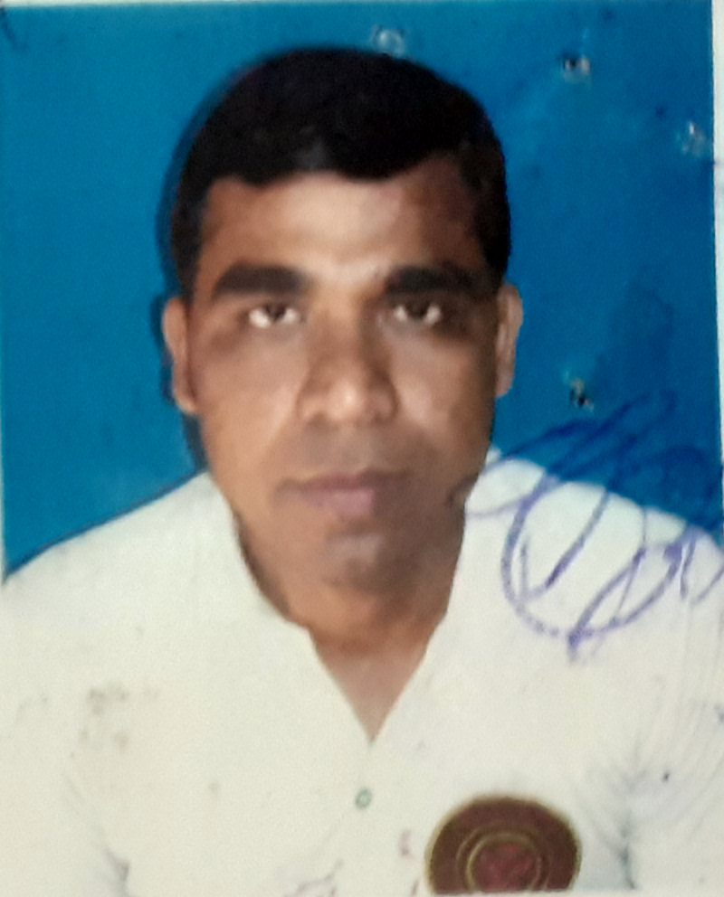
Roll No. | PKC/Gr-IV/011
Candidate’s Name | PRADIP DEKA
Father’s Name | LATE SISHU RAM DEKA
Address | VILL- AGDALA  PO & PS- BAIHATA CHARIALI  PIN-781381  PH NO.-9101059413

Candidate signature
Instruction to candidates

- Candidate must bring his/her admit card and all original testimonials along with xerox copy with him/her on the interview date.
- Candidate must reach the venue by 9:30 a.m.
- Admission of the candidate into the examination hall after 10 minutes of commencement of examination will not be allowed.
- Candidate will not be allowed to enter the examination hall with mobile phone and calculator or any other electronic devices.
- Candidate adopting unfair means will be disqualified.
- Candidate shall not be allowed to leave the examination hall without completing the stipulated time.
- Candidate need to carry at least one photo ID proof along with the admit card for verification purpose.
- In case of any error or misprint in the admit card, candidate must inform it to the invigilator.

OFFICE OF THE PRINCIPAL
PUB KAMRUP COLLEGE
P.O.: BAIHATA CHARIALI, DIST.: KAMRUP
ASSAM, PIN-781381

Website: www.pubkamrupcollege.in
Email: principal@pubkamrupcollege.org
principalpkc22@gmail.com
Ph: . 03621-286300, 8638375658 (M)

From:
Dr. Bhupen Kr. Sarma, M.Sc.,LLB, Ph.D
Principal

ADMIT CARD

Recruitment for the post of Grade-IV
Venue of examination: Pub Kamrup College, Baihata Chariali
Date of examination: 11-12-2022
Time: 10:00 a.m. to 11:00 a.m.

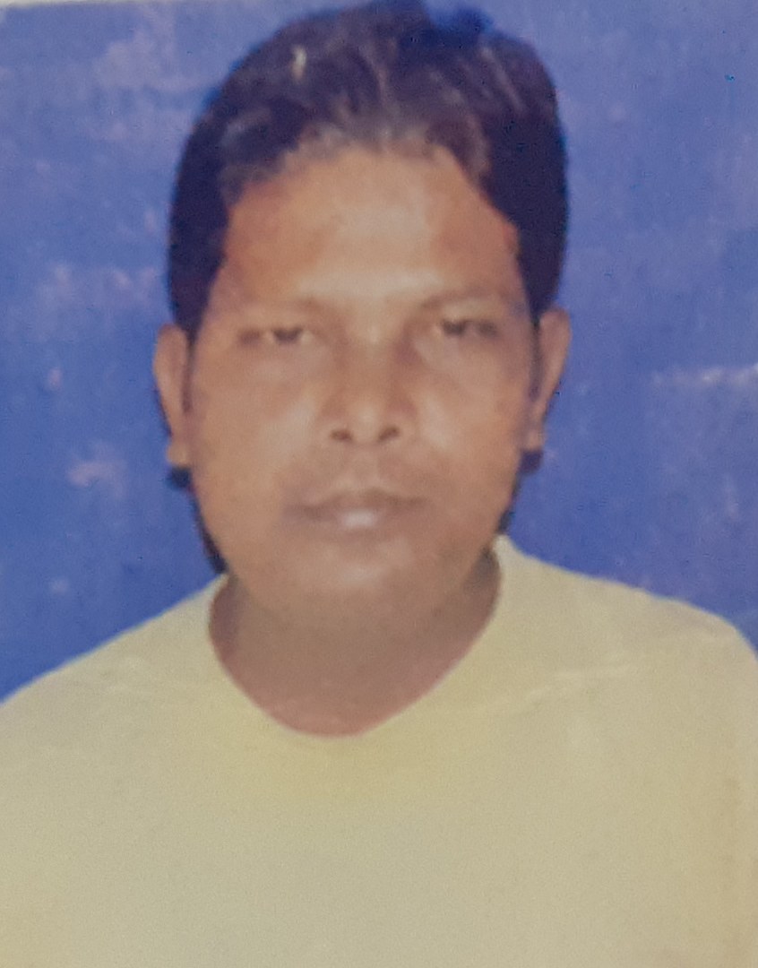
Roll No. | PKC/Gr-IV/027
Candidate’s Name | PRANAB DAS
Father’s Name | LATE JITEN DAS
Address | VILL- AGDALA  PO & PS- BAIHATA CHARIALI  PIN-781381  Candidate signature

Instruction to candidates

- Candidate must bring his/her admit card and all original testimonials along with xerox copy with him/her on the interview date.
- Candidate must reach the venue by 9:30 a.m.
- Admission of the candidate into the examination hall after 10 minutes of commencement of examination will not be allowed.
- Candidate will not be allowed to enter the examination hall with mobile phone and calculator or any other electronic devices.
- Candidate adopting unfair means will be disqualified.
- Candidate shall not be allowed to leave the examination hall without completing the stipulated time.
- Candidate need to carry at least one photo ID proof along with the admit card for verification purpose.
- In case of any error or misprint in the admit card, candidate must inform it to the invigilator.

OFFICE OF THE PRINCIPAL
PUB KAMRUP COLLEGE
P.O.: BAIHATA CHARIALI, DIST.: KAMRUP
ASSAM, PIN-781381

Website: www.pubkamrupcollege.in
Email: principal@pubkamrupcollege.org
principalpkc22@gmail.com
Ph: . 03621-286300, 8638375658 (M)

From:
Dr. Bhupen Kr. Sarma, M.Sc.,LLB, Ph.D
Principal

ADMIT CARD

Recruitment for the post of Grade-IV
Venue of examination: Pub Kamrup College, Baihata Chariali
Date of examination: 11-12-2022
Time: 10:00 a.m. to 11:00 a.m.

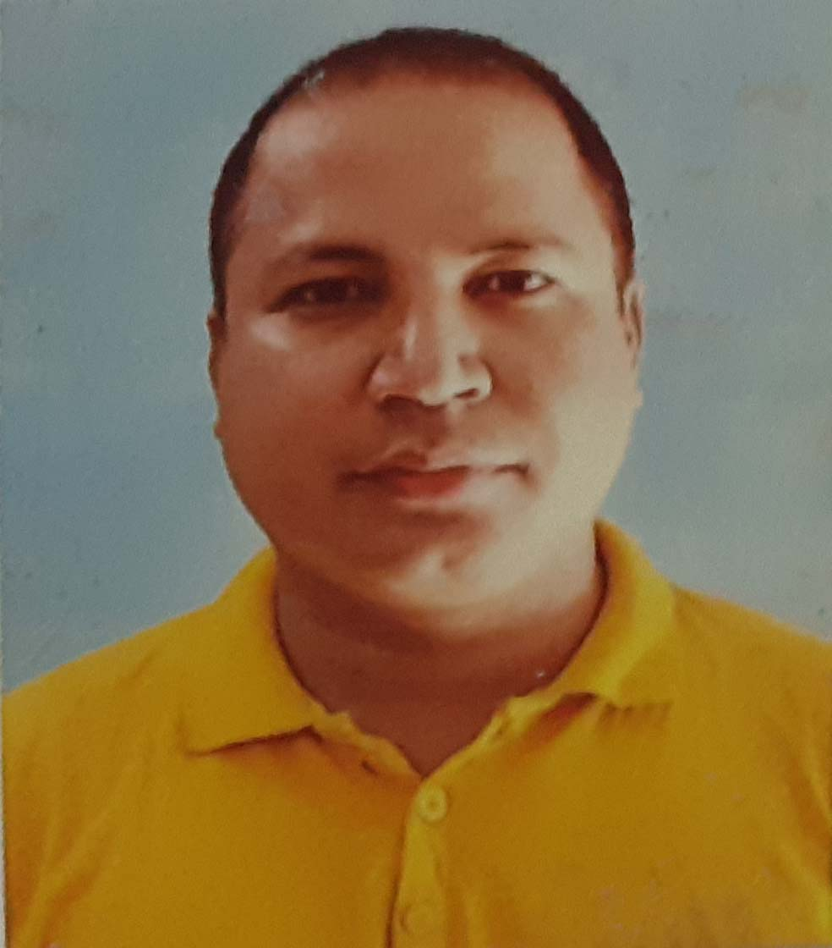
Roll No. | PKC/Gr-IV/005
Candidate’s Name | PRANAB SHYAM
Father’s Name | LOKESWAR SHYAM
Address | VILL- BACHAPATHAR  PO-DAPATHAR  PS-BARPATHAR  DIST-GOLAGHAT  PIN-785602

Candidate signature
Instruction to candidates

- Candidate must bring his/her admit card and all original testimonials along with xerox copy with him/her on the interview date.
- Candidate must reach the venue by 9:30 a.m.
- Admission of the candidate into the examination hall after 10 minutes of commencement of examination will not be allowed.
- Candidate will not be allowed to enter the examination hall with mobile phone and calculator or any other electronic devices.
- Candidate adopting unfair means will be disqualified.
- Candidate shall not be allowed to leave the examination hall without completing the stipulated time.
- Candidate need to carry at least one photo ID proof along with the admit card for verification purpose.
- In case of any error or misprint in the admit card, candidate must inform it to the invigilator.

OFFICE OF THE PRINCIPAL
PUB KAMRUP COLLEGE
P.O.: BAIHATA CHARIALI, DIST.: KAMRUP
ASSAM, PIN-781381

Website: www.pubkamrupcollege.in
Email: principal@pubkamrupcollege.org
principalpkc22@gmail.com
Ph: . 03621-286300, 8638375658 (M)

From:
Dr. Bhupen Kr. Sarma, M.Sc.,LLB, Ph.D
Principal

ADMIT CARD

Recruitment for the post of Grade-IV
Venue of examination: Pub Kamrup College, Baihata Chariali
Date of examination: 11-12-2022
Time: 10:00 a.m. to 11:00 a.m.


Roll No. | PKC/Gr-IV/008
Candidate’s Name | PRIYA BARUAH
Father’s Name | PRAHLAD BARUAH
Address | VILL- NIZ MADAR TOLA  PO & PS- BAIHATA CHARIALI  PIN-781381

Candidate signature

Instruction to candidates

- Candidate must bring his/her admit card and all original testimonials along with xerox copy with him/her on the interview date.
- Candidate must reach the venue by 9:30 a.m.
- Admission of the candidate into the examination hall after 10 minutes of commencement of examination will not be allowed.
- Candidate will not be allowed to enter the examination hall with mobile phone and calculator or any other electronic devices.
- Candidate adopting unfair means will be disqualified.
- Candidate shall not be allowed to leave the examination hall without completing the stipulated time.
- Candidate need to carry at least one photo ID proof along with the admit card for verification purpose.
- In case of any error or misprint in the admit card, candidate must inform it to the invigilator.

OFFICE OF THE PRINCIPAL
PUB KAMRUP COLLEGE
P.O.: BAIHATA CHARIALI, DIST.: KAMRUP
ASSAM, PIN-781381

Website: www.pubkamrupcollege.in
Email: principal@pubkamrupcollege.org
principalpkc22@gmail.com
Ph: . 03621-286300, 8638375658 (M)

From:
Dr. Bhupen Kr. Sarma, M.Sc.,LLB, Ph.D
Principal

ADMIT CARD

Recruitment for the post of Grade-IV
Venue of examination: Pub Kamrup College, Baihata Chariali
Date of examination: 11-12-2022
Time: 10:00 a.m. to 11:00 a.m.


Roll No. | PKC/Gr-IV/007
Candidate’s Name | RAHUL KATHAR
Father’s Name | BISNU RAM KATHAR
Address | VILL & PO-TEPESIA  PS-SONAPUR  DIST-KAMRUP(M)  PIN-782402  PH NO.-6900570497

Candidate signature
Instruction to candidates

- Candidate must bring his/her admit card and all original testimonials along with xerox copy with him/her on the interview date.
- Candidate must reach the venue by 9:30 a.m.
- Admission of the candidate into the examination hall after 10 minutes of commencement of examination will not be allowed.
- Candidate will not be allowed to enter the examination hall with mobile phone and calculator or any other electronic devices.
- Candidate adopting unfair means will be disqualified.
- Candidate shall not be allowed to leave the examination hall without completing the stipulated time.
- Candidate need to carry at least one photo ID proof along with the admit card for verification purpose.
- In case of any error or misprint in the admit card, candidate must inform it to the invigilator.

OFFICE OF THE PRINCIPAL
PUB KAMRUP COLLEGE
P.O.: BAIHATA CHARIALI, DIST.: KAMRUP
ASSAM, PIN-781381

Website: www.pubkamrupcollege.in
Email: principal@pubkamrupcollege.org
principalpkc22@gmail.com
Ph: . 03621-286300, 8638375658 (M)

From:
Dr. Bhupen Kr. Sarma, M.Sc.,LLB, Ph.D
Principal

ADMIT CARD

Recruitment for the post of Grade-IV
Venue of examination: Pub Kamrup College, Baihata Chariali
Date of examination: 11-12-2022
Time: 10:00 a.m. to 11:00 a.m.


Roll No. | PKC/Gr-IV/022
Candidate’s Name | RAKESH DEKA
Father’s Name | GAKUL DEKA
Address | VILL- AGDALA  PO & PS- BAIHATA CHARIALI  PIN-781381  PH NO.-9101196069

Candidate signature
Instruction to candidates

- Candidate must bring his/her admit card and all original testimonials along with xerox copy with him/her on the interview date.
- Candidate must reach the venue by 9:30 a.m.
- Admission of the candidate into the examination hall after 10 minutes of commencement of examination will not be allowed.
- Candidate will not be allowed to enter the examination hall with mobile phone and calculator or any other electronic devices.
- Candidate adopting unfair means will be disqualified.
- Candidate shall not be allowed to leave the examination hall without completing the stipulated time.
- Candidate need to carry at least one photo ID proof along with the admit card for verification purpose.
- In case of any error or misprint in the admit card, candidate must inform it to the invigilator.

OFFICE OF THE PRINCIPAL
PUB KAMRUP COLLEGE
P.O.: BAIHATA CHARIALI, DIST.: KAMRUP
ASSAM, PIN-781381

Website: www.pubkamrupcollege.in
Email: principal@pubkamrupcollege.org
principalpkc22@gmail.com
Ph: . 03621-286300, 8638375658 (M)

From:
Dr. Bhupen Kr. Sarma, M.Sc.,LLB, Ph.D
Principal

ADMIT CARD

Recruitment for the post of Grade-IV
Venue of examination: Pub Kamrup College, Baihata Chariali
Date of examination: 11-12-2022
Time: 10:00 a.m. to 11:00 a.m.

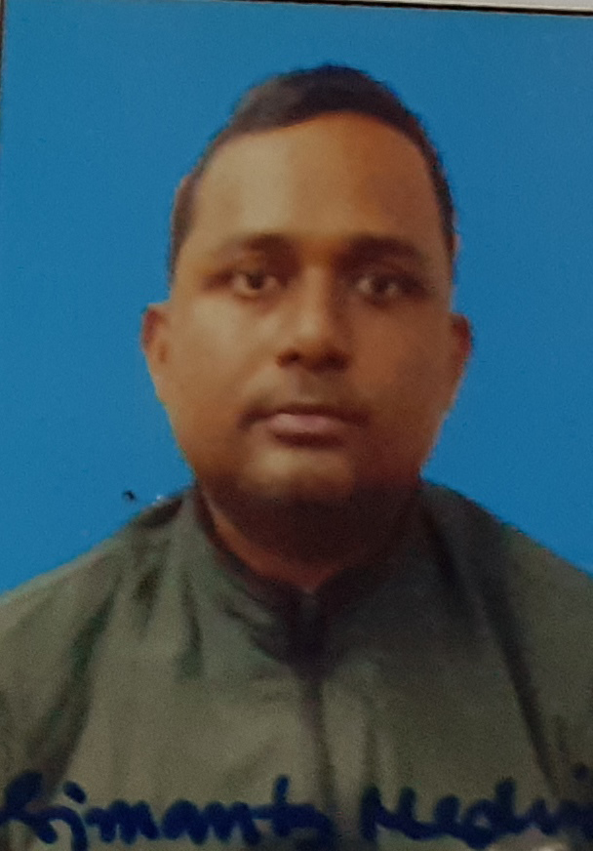
Roll No. | PKC/Gr-IV/025
Candidate’s Name | SIMANTA MEDHI
Father’s Name | AMRIT MEDHI
Address | VILL- MIRZAPUR (MAJPARA)  PO & PS- AZARA  DIST-KAMRUP (R)  PIN-781021  PH NO.-9854604589

Candidate signature
Instruction to candidates

- Candidate must bring his/her admit card and all original testimonials along with xerox copy with him/her on the interview date.
- Candidate must reach the venue by 9:30 a.m.
- Admission of the candidate into the examination hall after 10 minutes of commencement of examination will not be allowed.
- Candidate will not be allowed to enter the examination hall with mobile phone and calculator or any other electronic devices.
- Candidate adopting unfair means will be disqualified.
- Candidate shall not be allowed to leave the examination hall without completing the stipulated time.
- Candidate need to carry at least one photo ID proof along with the admit card for verification purpose.
- In case of any error or misprint in the admit card, candidate must inform it to the invigilator.

OFFICE OF THE PRINCIPAL
PUB KAMRUP COLLEGE
P.O.: BAIHATA CHARIALI, DIST.: KAMRUP
ASSAM, PIN-781381

Website: www.pubkamrupcollege.in
Email: principal@pubkamrupcollege.org
principalpkc22@gmail.com
Ph: . 03621-286300, 8638375658 (M)

From:
Dr. Bhupen Kr. Sarma, M.Sc.,LLB, Ph.D
Principal

ADMIT CARD

Recruitment for the post of Grade-IV
Venue of examination: Pub Kamrup College, Baihata Chariali
Date of examination: 11-12-2022
Time: 10:00 a.m. to 11:00 a.m.

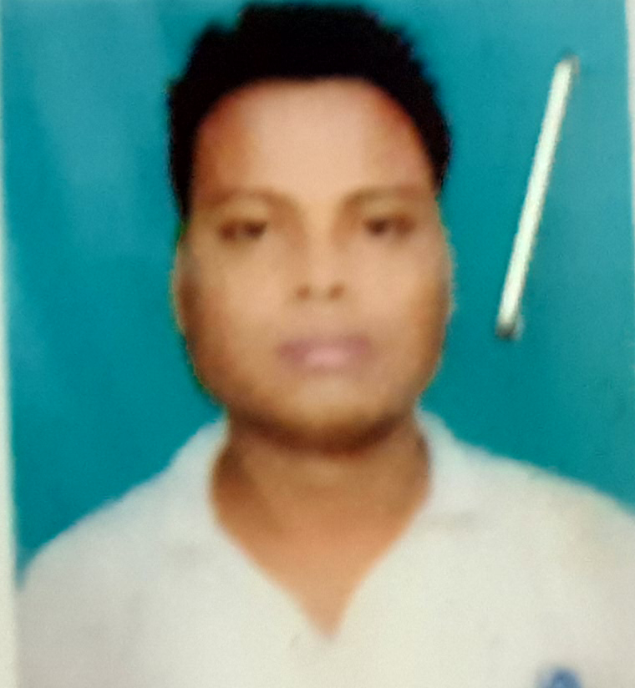
Roll No. | PKC/Gr-IV/032
Candidate’s Name | TAPAN RAJBONGSHI
Father’s Name | JOYDEV RAJBONGSHI
Address | VILL- NAGAON  PO & PS- BAIHATA CHARIALI  PIN-781381  PH NO.-9706710578

Candidate signature
Instruction to candidates

- Candidate must bring his/her admit card and all original testimonials along with xerox copy with him/her on the interview date.
- Candidate must reach the venue by 9:30 a.m.
- Admission of the candidate into the examination hall after 10 minutes of commencement of examination will not be allowed.
- Candidate will not be allowed to enter the examination hall with mobile phone and calculator or any other electronic devices.
- Candidate adopting unfair means will be disqualified.
- Candidate shall not be allowed to leave the examination hall without completing the stipulated time.
- Candidate need to carry at least one photo ID proof along with the admit card for verification purpose.
- In case of any error or misprint in the admit card, candidate must inform it to the invigilator.

OFFICE OF THE PRINCIPAL
PUB KAMRUP COLLEGE
P.O.: BAIHATA CHARIALI, DIST.: KAMRUP
ASSAM, PIN-781381

Website: www.pubkamrupcollege.in
Email: principal@pubkamrupcollege.org
principalpkc22@gmail.com
Ph: . 03621-286300, 8638375658 (M)

From:
Dr. Bhupen Kr. Sarma, M.Sc.,LLB, Ph.D
Principal

ADMIT CARD

Recruitment for the post of Grade-IV
Venue of examination: Pub Kamrup College, Baihata Chariali
Date of examination: 11-12-2022
Time: 10:00 a.m. to 11:00 a.m.


Roll No. | PKC/Gr-IV/001
Candidate’s Name | THANGMINHAO HAOLAI
Father’s Name | JANGKHOLAL HAOLAI
Address | SONGPIJANG, HAFLONG, DIMA HASAO, ASSAM  P.O & P.S.- HAFLONG  Candidate signature  PH NO.-6901625306

Instruction to candidates

- Candidate must bring his/her admit card and all original testimonials along with xerox copy with him/her on the interview date.
- Candidate must reach the venue by 9:30 a.m.
- Admission of the candidate into the examination hall after 10 minutes of commencement of examination will not be allowed.
- Candidate will not be allowed to enter the examination hall with mobile phone and calculator or any other electronic devices.
- Candidate adopting unfair means will be disqualified.
- Candidate shall not be allowed to leave the examination hall without completing the stipulated time.
- Candidate need to carry at least one photo ID proof along with the admit card for verification purpose.
- In case of any error or misprint in the admit card, candidate must inform it to the invigilator.

OFFICE OF THE PRINCIPAL
PUB KAMRUP COLLEGE
P.O.: BAIHATA CHARIALI, DIST.: KAMRUP
ASSAM, PIN-781381

Website: www.pubkamrupcollege.in
Email: principal@pubkamrupcollege.org
principalpkc22@gmail.com
Ph: . 03621-286300, 8638375658 (M)

From:
Dr. Bhupen Kr. Sarma, M.Sc.,LLB, Ph.D
Principal

ADMIT CARD

Recruitment for the post of Grade-IV
Venue of examination: Pub Kamrup College, Baihata Chariali
Date of examination: 11-12-2022
Time: 10:00 a.m. to 11:00 a.m.


Roll No. | PKC/Gr-IV/019
Candidate’s Name | TRAILOKYA SARMA
Father’s Name | MAHENDRA NATH SARMA
Address | VILL- AGDALA  PO & PS- BAIHATA CHARIALI  PIN-781381

Candidate signature
Instruction to candidates

- Candidate must bring his/her admit card and all original testimonials along with xerox copy with him/her on the interview date.
- Candidate must reach the venue by 9:30 a.m.
- Admission of the candidate into the examination hall after 10 minutes of commencement of examination will not be allowed.
- Candidate will not be allowed to enter the examination hall with mobile phone and calculator or any other electronic devices.
- Candidate adopting unfair means will be disqualified.
- Candidate shall not be allowed to leave the examination hall without completing the stipulated time.
- Candidate need to carry at least one photo ID proof along with the admit card for verification purpose.
- In case of any error or misprint in the admit card, candidate must inform it to the invigilator.

OFFICE OF THE PRINCIPAL
PUB KAMRUP COLLEGE
P.O.: BAIHATA CHARIALI, DIST.: KAMRUP
ASSAM, PIN-781381

Website: www.pubkamrupcollege.in
Email: principal@pubkamrupcollege.org
principalpkc22@gmail.com
Ph: . 03621-286300, 8638375658 (M)

From:
Dr. Bhupen Kr. Sarma, M.Sc.,LLB, Ph.D
Principal

ADMIT CARD

Recruitment for the post of Grade-IV
Venue of examination: Pub Kamrup College, Baihata Chariali
Date of examination: 11-12-2022
Time: 10:00 a.m. to 11:00 a.m.


Roll No. | PKC/Gr-IV/012
Candidate’s Name | TULIKA DEKA
Father’s Name | NAGEN DEKA
Address | VILL- SAJEI  PO-DAGAON  PS-BAIHATA CHARIALI  PIN-781133

Candidate signature
Instruction to candidates

- Candidate must bring his/her admit card and all original testimonials along with xerox copy with him/her on the interview date.
- Candidate must reach the venue by 9:30 a.m.
- Admission of the candidate into the examination hall after 10 minutes of commencement of examination will not be allowed.
- Candidate will not be allowed to enter the examination hall with mobile phone and calculator or any other electronic devices.
- Candidate adopting unfair means will be disqualified.
- Candidate shall not be allowed to leave the examination hall without completing the stipulated time.
- Candidate need to carry at least one photo ID proof along with the admit card for verification purpose.
- In case of any error or misprint in the admit card, candidate must inform it to the invigilator.

OFFICE OF THE PRINCIPAL
PUB KAMRUP COLLEGE
P.O.: BAIHATA CHARIALI, DIST.: KAMRUP
ASSAM, PIN-781381

Website: www.pubkamrupcollege.in
Email: principal@pubkamrupcollege.org
principalpkc22@gmail.com
Ph: . 03621-286300, 8638375658 (M)

From:
Dr. Bhupen Kr. Sarma, M.Sc.,LLB, Ph.D
Principal

ADMIT CARD

Recruitment for the post of Grade-IV
Venue of examination: Pub Kamrup College, Baihata Chariali
Date of examination: 11-12-2022
Time: 10:00 a.m. to 11:00 a.m.

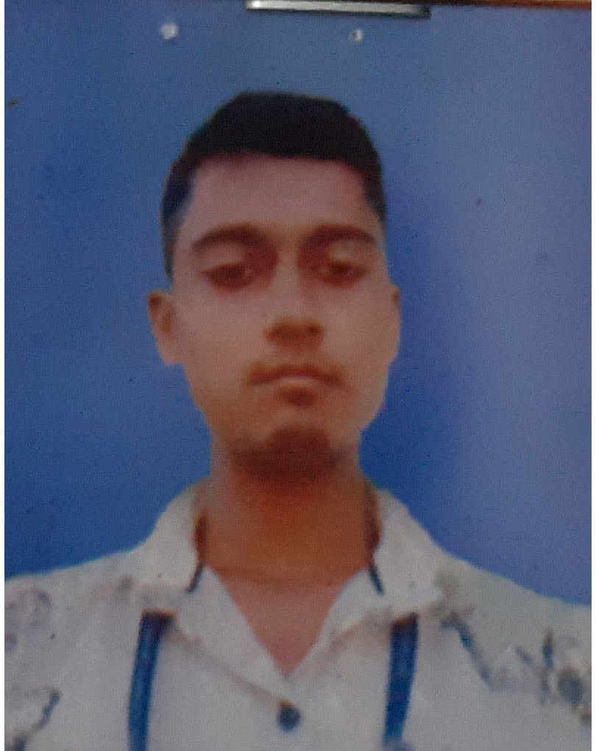
Roll No. | PKC/Gr-IV/036
Candidate’s Name | UTPAL KUMAR
Father’s Name | SIVA KUMAR
Address | VILL- GANAKJHAR  PO-MAHAJANPARA  PS-BAIHATA CHARIALI  PIN-781366  PH NO.-

Candidate signature
Instruction to candidates

- Candidate must bring his/her admit card and all original testimonials along with xerox copy with him/her on the interview date.
- Candidate must reach the venue by 9:30 a.m.
- Admission of the candidate into the examination hall after 10 minutes of commencement of examination will not be allowed.
- Candidate will not be allowed to enter the examination hall with mobile phone and calculator or any other electronic devices.
- Candidate adopting unfair means will be disqualified.
- Candidate shall not be allowed to leave the examination hall without completing the stipulated time.
- Candidate need to carry at least one photo ID proof along with the admit card for verification purpose.
- In case of any error or misprint in the admit card, candidate must inform it to the invigilator.

